1. Creating and Renaming Files/Directories

Objective

To create a directory, create a file inside

it, and rename the file.

Commands Used

mkdir test_dir

touch test_dir/example.txt

mv test_dir/example.txt test_dir/renamed_example.txt

echo $?

Explanation

mkdir creates a new directory.

touch creates an empty file.

mv renames the file.

echo $? shows the exit status (0 means success).

Output

0

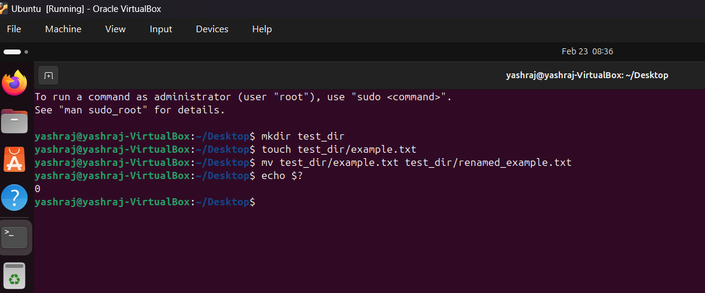

2. Viewing File Contents

Objective
To display the contents of a file using different commands.

Commands Used
cat /etc/passwd
head -n 5 /etc/passwd
tail -n 5 /etc/passwd

Explanation
The cat command displays the contents of a file in the terminal.
/etc/passwd is a system file that stores information about user accounts in Linux.

Output (Sample)
root:x:0:0:root:/root:/bin/bash
daemon:x:1:1:daemon:/usr/sbin:/usr/sbin/nologin

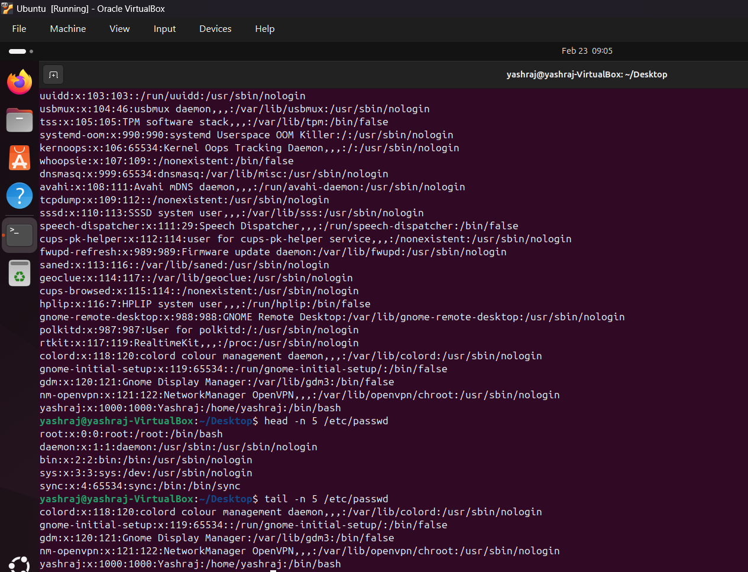

3.Searching for Patterns

Objective
To search for specific text inside a file.

Command Used
grep "root" /etc/passwd

Explanation
The grep command searches for lines containing the word "root" in the /etc/passwd file and displays all matching lines.
- grep → searches for text
- "root" → word to search
- /etc/passwd → file being searched

Output (Sample)
root:x:0:0:root:/root:/bin/bash
nm-openvpn:x:121:122:NetworkManager OpenVPN.../chroot:/usr/sbin/nologin

4. Zipping and Unzipping

Objective
To compress and extract a directory.

Commands Used
zip -r test_dir.zip test_dir
ls
unzip test_dir.zip -d unzipped_dir
ls unzipped_dir

Explanation
- zip -r compresses a directory recursively.
- ls verifies file creation.
- unzip -d extracts files into a specific directory.

Output (Sample)
adding: test_dir/
adding: test_dir/renamed_example.txt
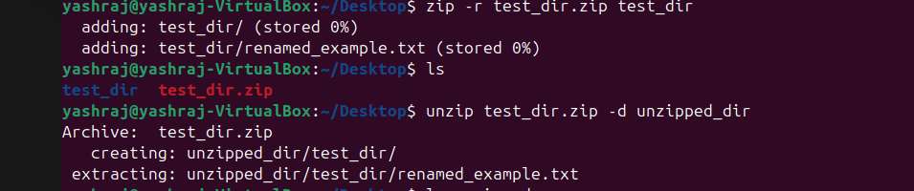

5. Downloading Files

Objective
To download a file from the internet.

Commands Used
wget https://google.com/robots.txt
ls

Explanation
The wget command downloads a file from a URL and saves it locally.

Output (Sample)
Saving to: ‘robots.txt’
‘robots.txt’ saved

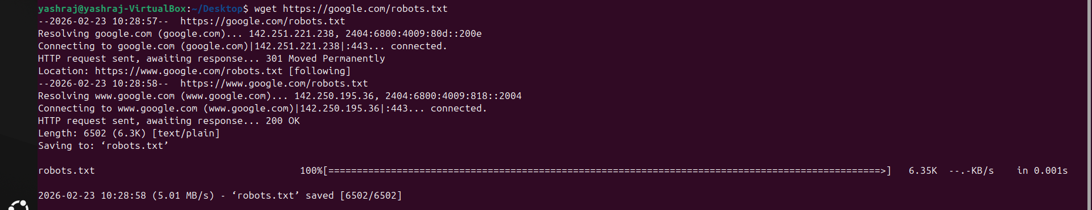

6. Changing Permissions

Objective
To change file permissions to read-only.

Commands Used
touch secure.txt
chmod 444 secure.txt
ls -l secure.txt

Explanation
- touch creates a file.
- chmod 444 sets read-only permission for all users.
- ls -l verifies permissions.

Output
-r--r--r--



7. Working with Environment Variables

Objective
To create and display an environment variable.

Commands Used
export MY_VAR="Hello World"
echo $MY_VAR

Explanation
- export creates a new environment variable.
- echo $MY_VAR displays its value.

Output
Hello World

